Flotsam Cache Settings
OpenSimulator has an asset cache that stores the assets retrieved from an asset service. This reduces the load on an asset service and improves OpenSimulator responsiveness. 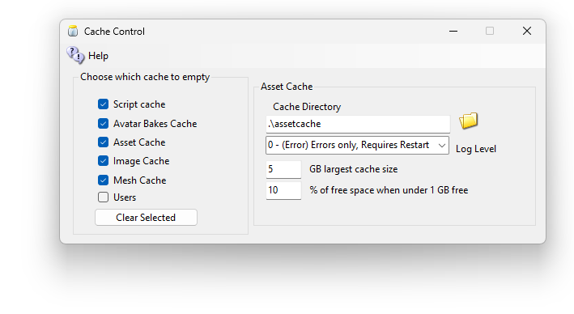Script Cache holds all of the compiled scripts. Clearing it deletes them all, and each script compiles again the next time its region starts. That is why it can only be cleared while OpenSimulator is stopped.
Avatar Bakes cache holds the combined layers of the avatars. These consist of the Skin, Alpha, Tattoo, and other layers.
Asset Cache stores the prims and meshes.
Image catches the images.
Users Cache maintains the Users home location, and other important parameters. This is a last resort cache that will clear ALL user data except login data.
Flotsam asset cache stores assets on disk.
DreamGrid keeps the asset cash from growing too large. You set the limit on this screen.

How big the asset cache can get
All of your regions share one asset cash. Every 15 minutes, DreamGrid checks how big it is. If it is over the limit, DreamGrid deletes the files that have gone unused the longest, until the cache is a little under the limit.
The limit depends on how much free space is left on the drive that holds the cache:
- If the drive has at least as much free space as the “GB largest cache size” box (5 GB unless you change it), the cache can grow to that size.
- If the drive has less free space than that, the cache is kept to 1 GB.
- If the drive has less than 1 GB free, the cache is kept to the “% of free space” box (10 % unless you change it) of whatever space is left.
Deleting cache files is safe. When a region needs one of those assets again, it simply fetches it from the grid.
The Cache Directory box shows where the asset cache lives. Click the folder button to move it, for example to a bigger drive. The limit is then measured on that drive.
Older versions of DreamGrid had a “Timeout in hours” box instead. It is gone. OpenSimulator no longer cleans the cache itself: every region did it at the same moment, they got in each other’s way, and the logs filled with “Access to the path is denied” warnings.

General principles
When OpenSimulator requires an asset (e.g., in response to a viewer request for a note card), then it first asks the cache for this data. If the data is not found in the cache, then it asks the grid asset service (or a foreign asset service in the case of Hypergrid). If the asset is there, then it is both stored in the cache and returned to the user.
If an asset is uploaded to OpenSimulator (e.g., by the viewer uploading an animation), then the asset is at kept in cache (if there is room and the asset is not temporary) and sent to the asset service (if the asset is not temporary).
Therefore, at any point you can wipe any temporary data stored by the asset cache (e.g., on the filesystem), since the next request for that asset will simply query the asset service.

